Machine Learning DAT5303
Attn: Professor Chase Kusterer

A2: Written Assessment (Individual) - Classification Modeling Case Study
Student: Neel Kiran Roshania ID 5054642
15 March 2020

A report submitted to Hult International Business School in partial fulfilment of Master of Business Administration.

Insight 1
The cross-selling strategy has introduced a new customer type; Halfway-There only subscribers. They account for nearly 25% of existing customers. All customers prefer to register with their mobile phones.
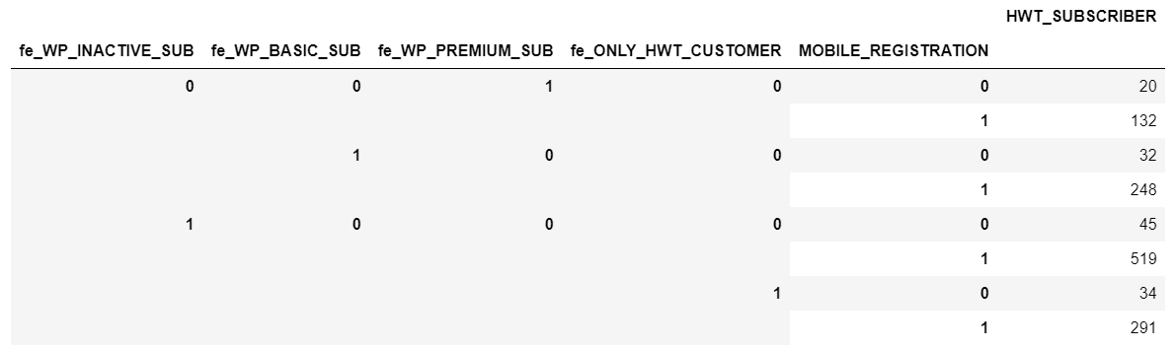

Insight 2
HWT only subscribers see value in the product as their spend is nearly a third of existing other customers.
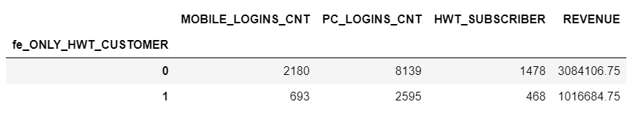

Key Recommendation
To drive cross-selling effectiveness, develop lists of recipes that can be paired with the wines you sell and optimize them for viewing on PC and Mobile.

